Lesson 8:
Discipling through Self-Sacrifice (Mark 8:31-38)

Self-Sacrificial Leadership (vs. 31-33)
- Self-sacrificial leaders endure hard things (vs. 31-32a).
  - Christ-like leaders suffer.
  - Christ-like leaders are rejected.
  - Christ-like leaders are sometimes martyrs.
  - Christ-like leaders overcome.
- Self-sacrificial leaders are countercultural (vs. 32b-33).
  - People scoff at this leadership style.
  - People question God’s plans.
  - People are clouded with worldly wisdom.

Self-Sacrificial Living (vs. 34-38)
- Consider what isn’t worth living for.
  - Living for yourself isn’t worth it.
  - Living for this world isn’t worth it.
- Consider what is worth living for.
  - Living for Jesus is worth it.
  - Living for His Gospel is worth it.

Prayer
Scripture: For the love of Christ constraineth us; because we thus judge, that if one died for all, then were all dead: And that he died for all, that they which live should not henceforth live unto themselves, but unto him which died for them, and rose again.
2 Corinthians 5:14-15

Single Focus/Cross Impact Requests:
- Cross Impact
  - Transfers
  - Open doors into some kind of group
  - Evangelistic Bible Studies
- Single Focus
  - Grow in Gospel partnership together
  - Discipleship ideas for our group
  - Outreach ideas with young adults in Indy
- Purdue Cross Impact Effort

Specific Requests:
- Dornbirers as dad goes through cancer treatments
- Matthew Kroeker’s family

Announcements:

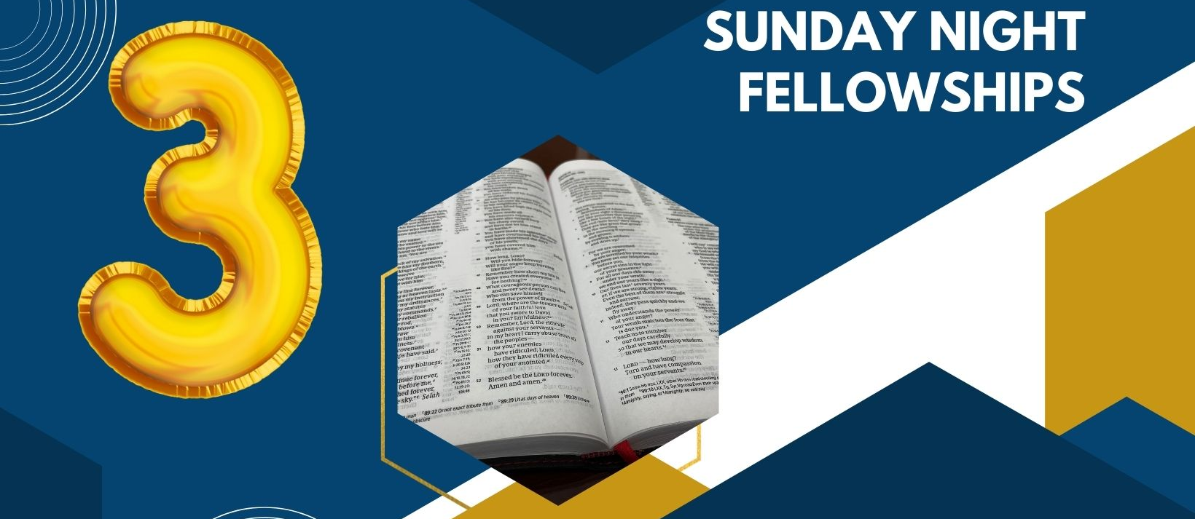
Sunday Notes:
- Small Groups:

- Sunday Morning:

- Sunday Evening

Prayer Requests:

