Lesson 5
Bearing Burdens Together
Galatians 6:1-5

We are all sinful people. Our sinfulness affects us, God, and others. Sin affects us by robbing us of our confidence, hindering our joy and peace, keeping us from being useful, and makes us weak to deceitful temptations. Sin affects God by hindering our relationship with Him and causing Him to feel grief over our sin. Sin affects others by infecting them and causing hurt and strife.
One of the most important foundations for Christian life is our personal and corporate holiness. Positively, God calls us to walk in holiness. Negatively, we need to correct those areas that are unholy. And for that reason, we need the church to be a place of bearing burdens. We fall, and need others to help us up. We are weak, and we need others to help sustain us. We see these things in others, and we need to step in. We must grasp the importance of bearing burdens together.

By helping each other up (v. 1).
- See your brother’s sin.
  - This sin was a surprise.
  - This sin was a mistake.
- Set your brother straight.
  - Help them with a gentle spirit..
  - Help them with a careful spirit.

By holding each other up (vs. 2-5).
- Hold each other up when pressure is great.
- Hold each other up with a motivation of love.
- Hold each other up with diligent watchfulness.
- Hold each other up without spiritual arrogance.
- Hold each other up while being personally responsible.

Prayer
Scripture: ²² But the fruit of the Spirit is love, joy, peace, longsuffering, gentleness, goodness, faith, ²³ meekness, temperance: against such there is no law…²⁵ If we live in the Spirit, let us also walk in the Spirit.
Galatians 5:22-23, 25

Single Focus/Cross Impact Requests:
- Cross Impact IUPUI
- Single Focus
- Purdue Cross Impact Efforts at Purdue & UIndy
- Sunday Soul-Winning Efforts

Specific Requests:
- Jack Elms, Kendall Elms, Jesiah Achenbach in military training/service
- Joseph LaPointe’s back and spirit
- Trevor’s need for community at Indiana State
- Jessica’s Unsaved friend in Mormonism
- Zirkles as Ronda goes through cancer treatments
- Caleb Williams’ Grandfather, Dwight, with cancer and sickness
- Xavion’s court date to not be moved again

Announcements:
- August 12- Indians Game
- August 16- Wednesday in the woods
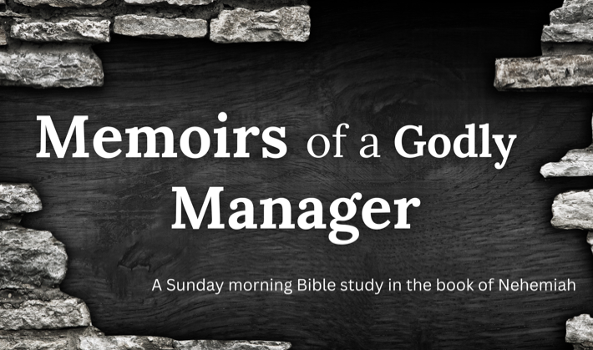

Order of Service for tonight:
- Opening Game:
  - Crazy Court Cases
- Announcements:
- Songs:
  - I Will Glory in My Redeemer- page 66
  - Abba Father- pages 8-9
  - He will Hold Me Fast (on screen)
- Prayer:
  - New Requests:
  - Other Requests:
- Message: Andy

