Leadership Lesson 2
Essential Qualities of Leadership
Part 1

Quality #1- Discipline (1 Cor. 9:24-27; 1 Tim. 4:7-8).

Discipline: “Spiritual discipline involves practicing intentional self-control in every aspect of life—physical, spiritual, mental, and beyond—to cultivate habits of character that result in a long-lasting influence.”

Christian leaders have a different lifestyle. To lead effectively, you must master your appetites, time, and habits. “Before we can conquer the world, we must first conquer the self.” Many skilled people fail because they lack discipline. As a Christian leader, you are called to discipline yourself. Discipline helps you grow in godliness. Discipline keeps you from wasting your life. By learning to deny yourself, you’re also learning to say “yes” to following God.

Quality #2: Vision (Prov. 29:18; Neh. 7, Luke 6:12-13; Rom. 15:23-24)

Vision: "The skill of looking into the future with a specific mission, understanding how to accomplish that mission, and inspiring others to join in that mission."

Every generation has needed leaders who can look ahead. God-led leaders prayerfully consider how they can change the world for God, and they make plans to do it! They see beyond the urgent to the big picture. Successful leaders are motivated by future goals and learn how to achieve them. Churches and organizations without vision usually die, but men and women with purposeful vision often change the world for the cause of Christ.

“Vision leads to venture, and history is on the side of venturesome faith.”

Quality #3: Wisdom (2 Chron. 1:7-12; Acts 6:3, Col. 1:9).

Wisdom: "The skill of discerning how to use knowledge to make quality decisions that accord with Scripture and honor God.”

God has always valued and increased the influence of leaders who seek wisdom. Christian leaders think differently. Solomon, nervous about leading the people of Israel, asked God for "wisdom and knowledge, that I may go out and come in before this people" (2 Chron. 1:10a). The first deacons were chosen to be men "full of the Holy Ghost and wisdom" (Acts 6:3). Paul prayed for the Colossians to have wisdom and understanding. Godly leaders need an extra measure of spiritual discernment to influence others well.

Quality #4: Decisiveness (Josh. 24:14-15; Gen. 13-14, Acts 22:10, Heb. 11)

Decisiveness: The ability of a leader to wisely evaluate information, seek guidance from the Holy Spirit, make wise choices in the right time and manner, and stay committed to those decisions.

“A visionary may see, but a leader must decide.” Godly leaders cannot waffle in indecision. Leadership requires decisive actions based on sound judgment rather than impulsivity. Abraham made swift action to rescue Lot (Gen. 14). People of character make commitments (Josh. 24:14-15; Luke 9:62). Indecision might masquerade as wisdom, but it’s often dangerous (1 Kings 18:21, James 1:8).

Quality #5: Courage (2 Tim. 1:7-8; Prov. 27:1, 1 Cor. 16:13; Eph. 6:10).

Courage: The mental and moral fortitude that confidently pushes past fear and obstacles, trusts God's sovereign control by faith, and motivates someone to push forward with excellence and zeal.

Leading by faith requires boldness. Every person wrestles with different types of fear, and countless Christian leaders have wrestled with that. But with an awareness of God’s presence, the control of the Holy Spirit, confident faith, and sound thinking, Christians can conquer those fears and lead with zeal.

“Courage is that quality of mind that enables people to encounter danger or difficulty firmly, without fear or discouragement.”

Quality #6: Humility (Phil. 2:3-8; Matt. 20:25-27, John 3:30).

Humility: The skill of looking into the future with a specific mission, understanding how to accomplish that mission, and inspiring others to join in that mission.

In a world where everyone asserts themselves, Christians are called to have a different mindset: humility. True leaders are servants. True leadership is sacrifice. True greatness is selfless. Andrew Murray once said, “Pride must die in you, or nothing of heaven can live in you.”

Quality #6: Integrity & Sincerity

Integrity: A character-filled life that can stand under scrutiny with a clear conscience and blameless conduct.

Sincerity: A genuine spirit that embraces truth and honesty in word and conduct. without hypocrisy, clearness, appropriate transparency

Leaders who are fake have superficial influence. It’s crucial for all believers to have transparency in their relationship with God and others, as people can tell when leaders are disingenuous. Someone with integrity backs up their beliefs with their actions. Integrity guides and protects those who have it (Prov. 10:9, 11:3; 1 Pet. 3:16), and those who foster of life integrity often demonstrate it through sincerity.

“A good character is the best tombstone. Those who loved you and were helped by you will remember you when forget-me-nots have withered. Carve your name on hearts, not on marble.”

Prayer
Scripture: Be careful for nothing; but in every thing by prayer and supplication with thanksgiving let your requests be made known unto God. And the peace of God, which passeth all understanding, shall keep your hearts and minds through Christ Jesus.
Philippians 4:6-7

Single Focus/Cross Impact Requests:
- Single Focus (Connect, Grow, Serve)
  - Midwest Young Adults Conference
  - Community over the summer season
- Cross Impact IUPUI, Purdue, Ball State, and UIndy (potential at other campuses)
- Sunday Soul-Winning Efforts

Specific Requests:
- Jack Elms, Kendall Elms, Jesiah Achenbach, and Max Garcia in military training/service
- Joseph LaPointe’s back and spirit
- Jessica’s Unsaved friend in Mormonism
- Ian’s unsaved family
- James as he recovers from his diabetic episode and financial implications (Hau’s friend)
- Pastor Jonah Scott (Andy’s friend in WI) recovering at home after all of his dramatic health issues. Pray for continued recovery physically, mentally, and spiritually.
- Those heading out for the summer to camps and other ministries and jobs: Joel Montgomery, Emma Reasen, John Barfield, Steven Platt, Ashlyn Moritz

Announcements:
- Missions Trip- July 19-21 (Due date to sign up, June 12)
- Involvement this Summer (Sunday Morning Bible Study, Wednesdays, coffee bar)

Order of Service for tonight:
- Opening Game: Picture Puzzles- Summer Edition
- Opener: Liam Donovan
- Songs:
  - My Hope is In the Lord (on screen)
  - I Am With You (p. 158)
- Prayer: Liam Donovan
- Announcements: Pastor Andy
- Message: Pastor Andy

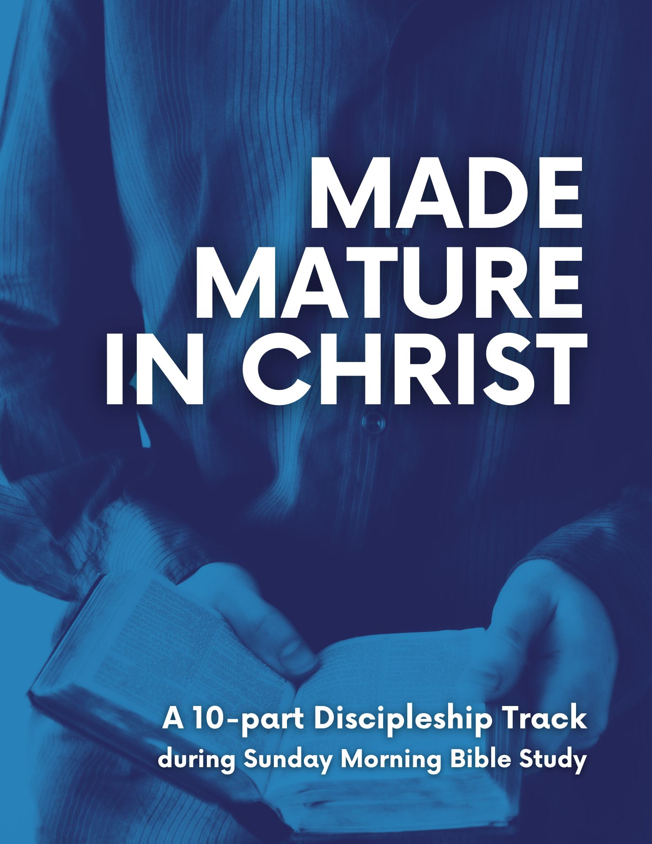

These six leadership qualities are provided in chapter 8 of Oswald Sander’s book, “Spiritual Leadership: Principles of Excellence for Every Believer.”
Sanders, p. 61.
Sanders, p. 66.
Sanders, p. 69.
Sanders, p. 70.
C.H. Spurgeon

