Lesson 2
“”
Revelation 2:1-7

Anyone

The Character of Christ (Rev. 2:1)
- Jesus’ posture: he that holdeth the seven stars in his right hand

- Jesus’ position: walking among the 7 candlesticks

The Culture of the Church- Ephesus (2:1a)
- Politically, Ephesus was influential.
- Geographically, Ephesus was strategic.
- Structurally (architecturally), Ephesus was powerful.
- Economically, Ephesus was rich.
- Religiously, Ephesus was cultic.
- Morally, Ephesus was sexualized.

The Compliments for the Church (2:2-3, 6)
- The worked hard in ministry.
- The persevered in difficulty.
- They resisted sinful influences.
- They wisely discerned false teachers.
- They endured in patience when they were weary.
- They hated heresy in a Christ-like way.

The Criticisms of the Church (2:4)
- You abandoned your first love.
- You fell from your first love.

The Corrections for the Church (2:
- Wrongly motivated Christians need to remember their first love.
- Wrongly motivated Christians need to repent of their lack of love.
- Wrongly motivated Christians need to return to what they used to do.

The Consequences for the Church
- Jesus Christ will come to them quickly.
- The church will die eventually.

The Call to the Churches
- He that hath an ear, let Him hear.

The Conquering of the Church
- They will eat from the tree of life.
- They will dwell in God's paradise.

Prayer
Scripture: Let us therefore come boldly unto the throne of grace, that we may obtain mercy, and find grace to help in time of need.
Hebrews 4:16

Single Focus/Cross Impact Requests:
- Cross Impact IUPUI, Purdue, and UIndy
- Single Focus
  - College Students while they’re away
  - Year-Long atmosphere and discipleship at home
- Sunday Soul-Winning Efforts

Specific Requests:
- Jack Elms, Kendall Elms, Jesiah Achenbach in military training/service
- Joseph LaPointe’s back and spirit
- Trevor’s need for community at Indiana State
- Jessica’s Unsaved friend in Mormonism
- Zirkles as Ronda goes through cancer treatments
- Xavion’s court situation
- Sarah’s family’s salvation

Announcements:
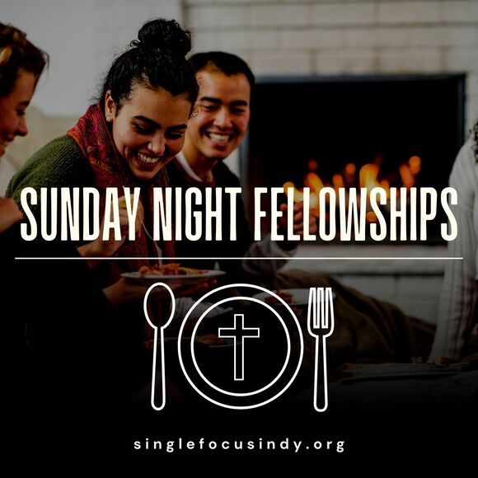
- September 8- Men’s Bible Study
- September 10- SNF at the Knoedler’s
- Week of 11-15- Top Golf (Tuesday is cheapest)

Order of Service for tonight:
Service Theme: “Come Boldly”
- Opening Game: “Who Am I?”
- Announcements:
  - Sunday Night Fellowship at the Knoedlers
- Opener: Brandon
- Songs:
  - My Jesus, Fair- page 87/ Screen
    - Private Prayer
  - Christ is Sufficient - Sheet Music / Screen
    - Corporate Praise/ Prayer
  - Arise, My Soul, Arise - Sheet Music/ Screen
    - Small Group Supplication
Message: Pastor Andy

