Lesson 17
“Let’s Sum It All Up”
Ecclesiastes 12:9-14
We finally reach the end of Ecclesiastes. The conclusion here is not just a restatement of what has been said; it’s the culmination of everything. These 12 chapters have built up to one ultimate, simple conclusion that deserves our full attention. This encapsulates the essence of the entire journey we’ve undertaken through the book.

Like a mountain range, Ecclesiastes is filled with both peaks and valleys. Under the sun, life is vanity, temporary, “poof” (hevel). It’s like chasing after the wind. In the fear of God, life is worth living. We’ve seen valleys of unfairness, our inability to control our lives, and the limits of wisdom. But the ultimate conclusion of this book is glorious. It takes us to the summit, where the view is clear and the lesson is life-changing: Center your life in the fear of God.

Ponder Solomon’s Dedication, Designed to Teach You (vs. 9-10).
- He taught you with . (v. 9a).
- He taught you with (v. 9b).
  - the facts
  - Seeking the truth
  - the proverbs
- He taught you with (v. 10).
  - His proverbs were joyful.
  - His proverbs were - .
  - His proverbs were true.

Other Notes:

Value His Advice, Given to Help You (vs. 11-12).
- You need words of (v. 11).
  - Wise words you.
  - Wise words advise you.
  - Wise words you.
- You don’t need knowledge (v. 12).

Other Notes:

Embrace the Ultimate Conclusion, Meant to Change You (vs. 13-14).
- Accept the admonitions (v. 13).
  - God.
  - God.
- Realize the reasons why (vs. 13b-14).
  - God should be your in life.
  - God will hold you for your life.

Other Notes:

Prayer
Scripture: ¹ Then I will life up mine eyes unto the hills, from whence cometh my help. ² My help cometh from the Lord, which made heaven and earth. ⁸ The Lord shall preserve thy going out and thy coming in from this time forth, and even for evermore.
Psalm 121:1-2, 8

Single Focus/Cross Impact Requests:
- Single Focus (Connect, Grow, Serve)
  - College Student Welcome Home
  - Midwest Young Adults Conference
  - Community over the summer season
- Cross Impact IUPUI, Purdue, Ball State, and UIndy (potential at other campuses)
- Sunday Soul-Winning Efforts

Specific Requests:
- Jack Elms, Kendall Elms, Jesiah Achenbach, and Max Garcia in military training/service
- Joseph LaPointe’s back and spirit
- Jessica’s Unsaved friend in Mormonism
- Ian’s unsaved family
- James as he recovers from his diabetic episode and financial implications (Hau’s friend)
- Karen’s (Elizabeth’s coworker) continued complications from her surgery months ago
- Jessi Gold’s search for an internship.
- Pastor Jonah Scott (Andy’s friend in WI) still fighting the infection that caused sepsis. Lots of ups and downs right now: praying to be home by the end of June.

Announcements:
- College Student Welcome-Home event- May 17
- Midwest Young Adults Conference- June 1
- Midweek Connection Openers and Music Schedule

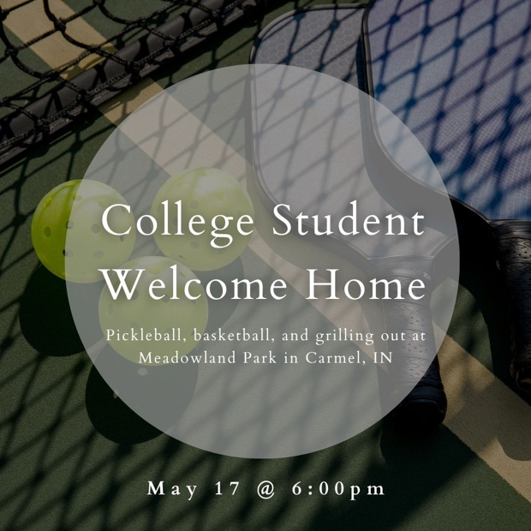

Order of Service for tonight:
- Opening Game: College Courses- Real or Fake?
- Announcements: Andy
- Opener: Matt Ashley
- Songs:
  - Walk Worthy (on screen)
  - Mercies Anew (on screen)
- Prayer: Matt Ashley
- Message: Pastor Andy

